Jeda Krisnell Dionisio

PHILOS 12A / DIS 102

GSI: Mathias Boehm

Problem Set #10

Exercise 10.20

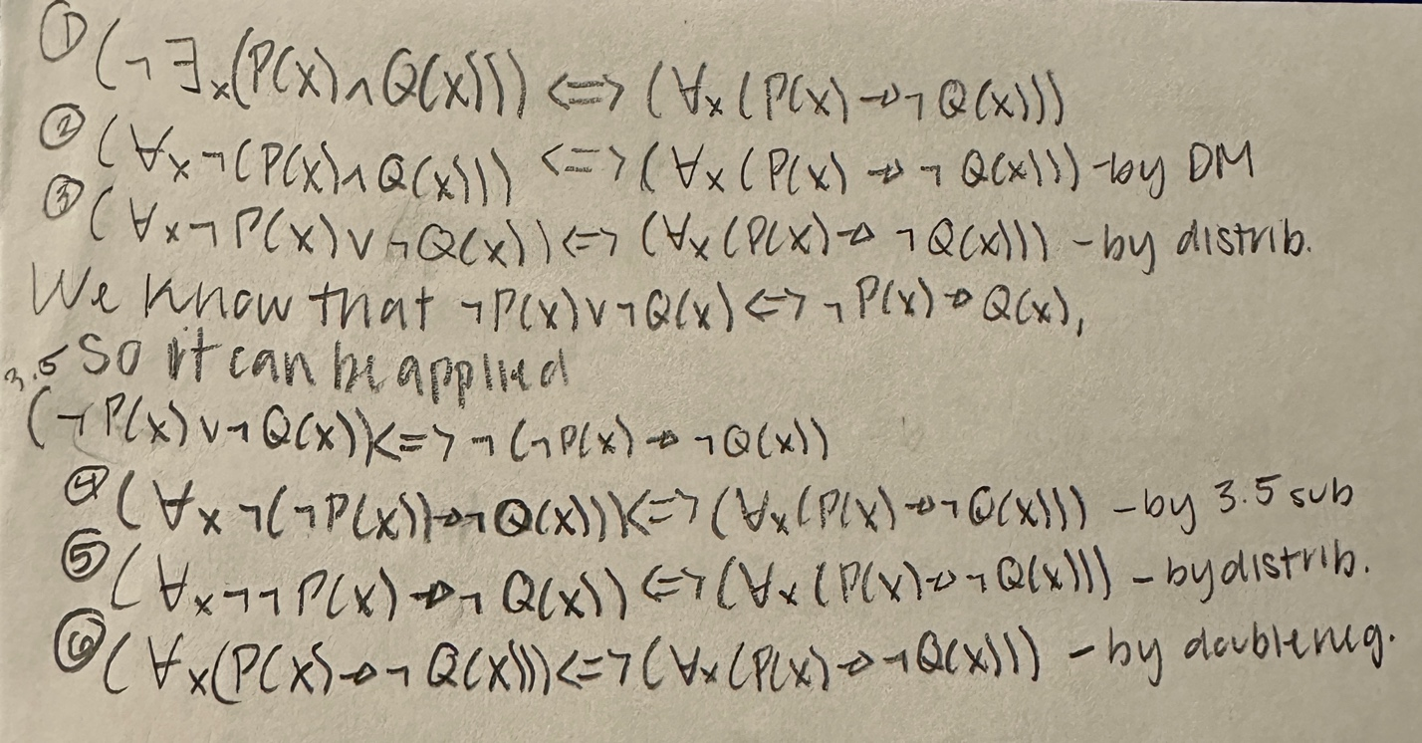

Exercise 10.31

1. Red, yellow, and blue in the domain of automobiles.

None of the axioms are satisfied.

Counterexample: The car could be black, which would not be able to satisfy everything.

1. Entirely red, entirely yellow, and entirely blue in the domain of automobiles.

The fourth axiom is not satisfied.

Counterexample: The car could be a different color unlike the ones given. Green could be one. Similarly, the car could be half of a color and half of another color.

1. Small, medium, and large in the domain of Tarski’s World blocks.

The axioms are satisfied.

1. Small, medium, and large in the domain of physical objects.

The fourth axiom is not satisfied.

Counterexample: The object could be characterized differently than the Small, Medium, and Large. It can be tiny or giant or average.